**Image 1: Homepage**

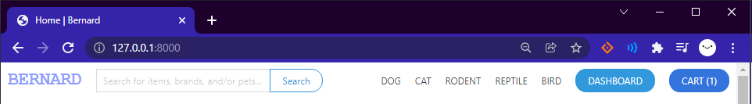

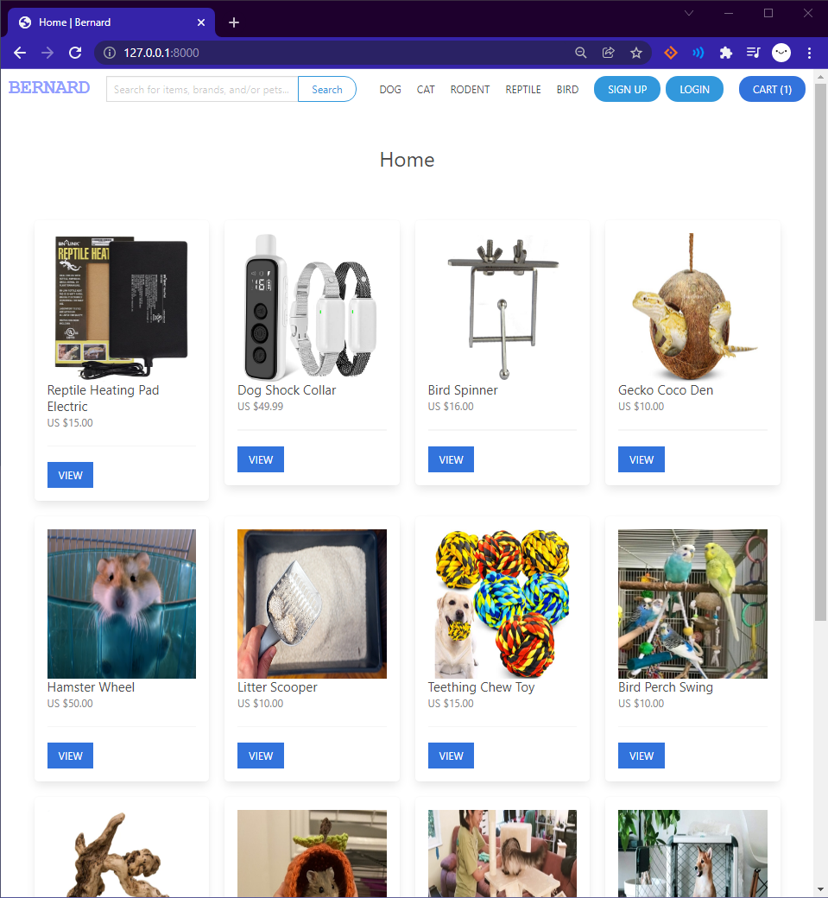

**Key Points/Changes:**

* Updates to Style, going for Blue colors for branding, Website name will be called Bernard, more on that on final site
* Added more categories that align with the common products on pet websites
* Added Cart button that shows when item is added
* Populated Local databases with items
* Admin page now titled Dashboard, and login and signup not top right

**Image 2: Cart**

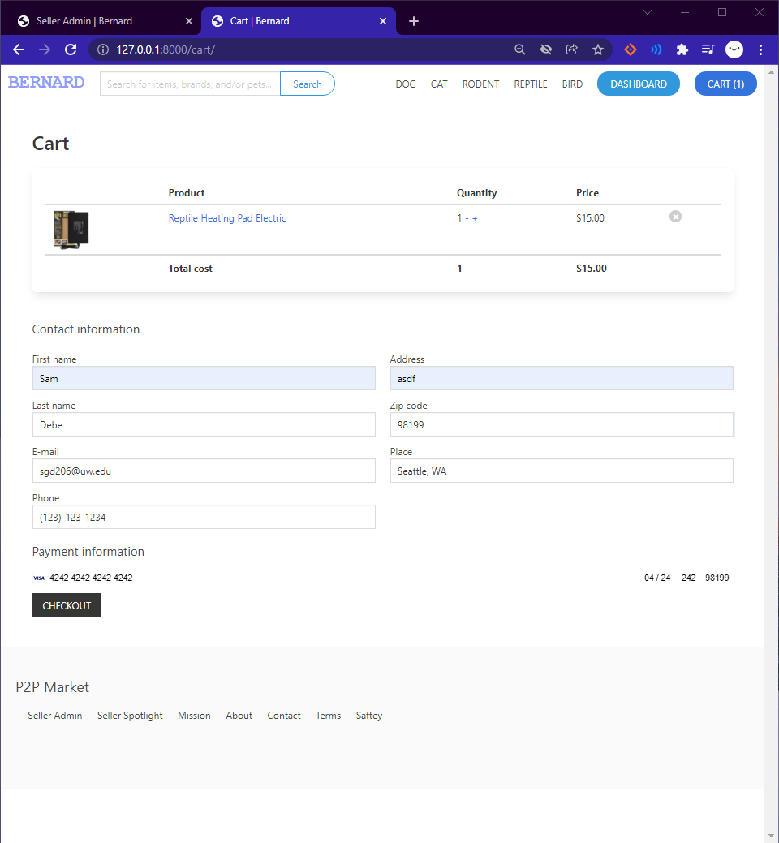

**Key Points:**

* New Cart interface
* Ability to remove add quantity for items list for more selling
* Log your contact info to be shared with the seller, and payment will be transferred through Stripe interface.
* Test key is activated in test mode
* 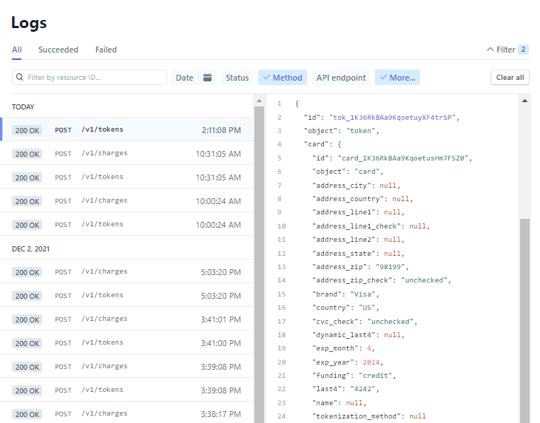

**Image 3: Seller Dashboard**

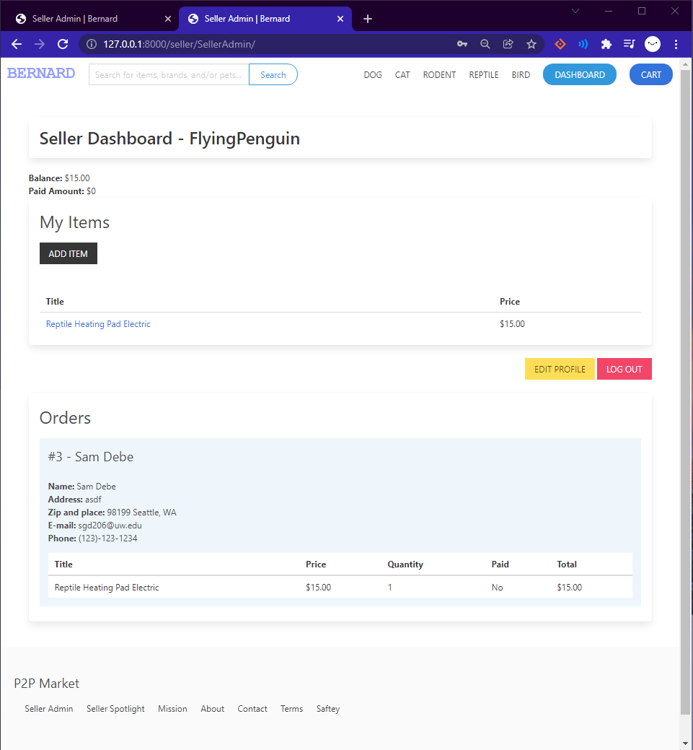

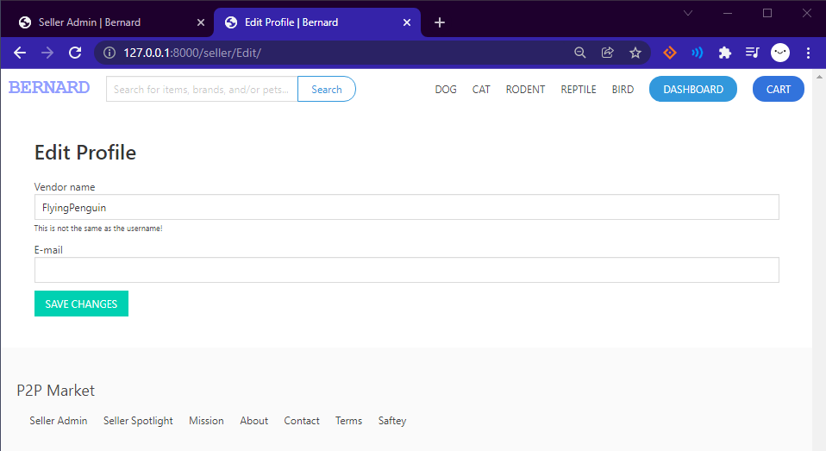

**Key Points:**

* Order was made from account JumpingGiraffe → FlyingPenguin
* Order list shared information of bought item with personal information to be sent and information to communicate
* Makes it so you can add email and change name, change to change authorizations

**Image 4: Item Page**

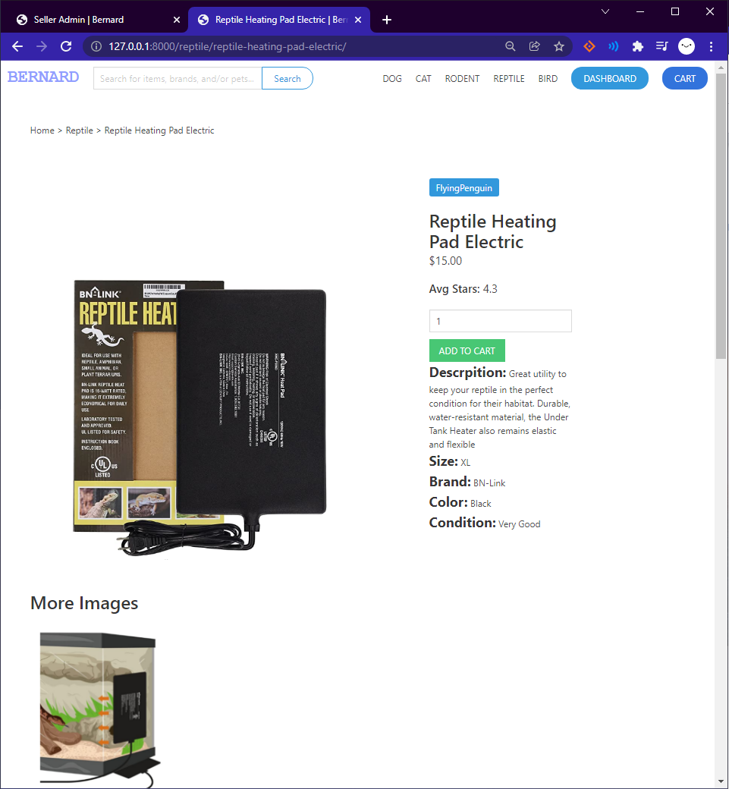

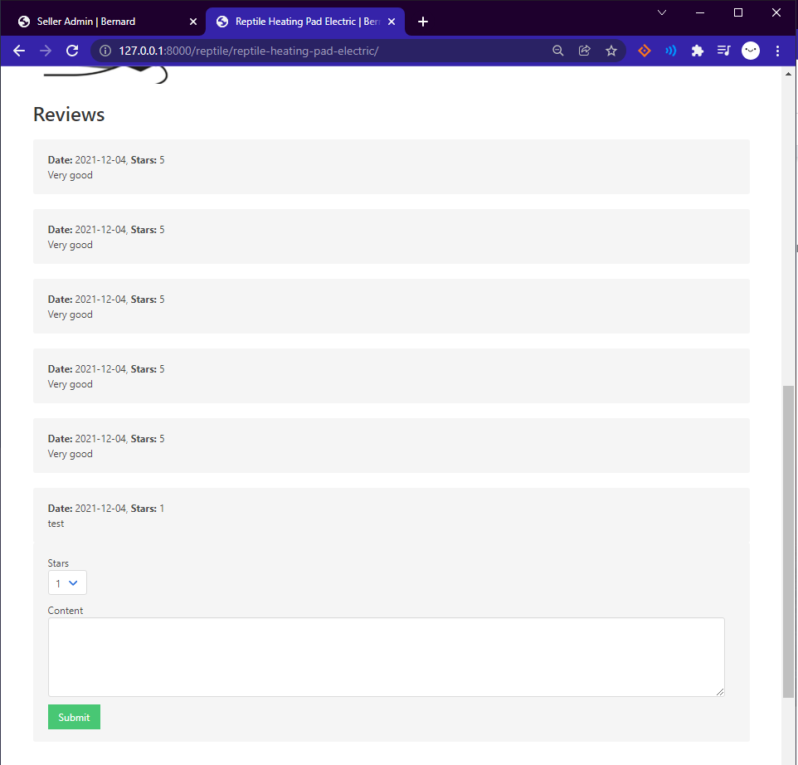

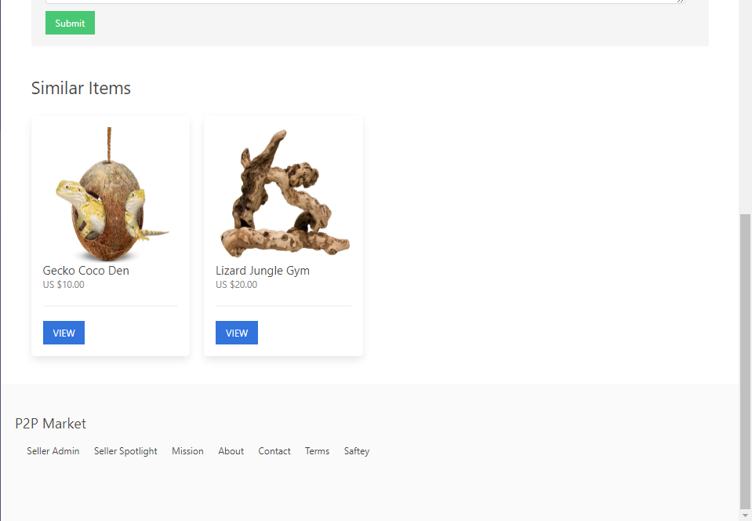

**Key Points:**

* Item now shows avg star views
* Includes more images
* Added a review system that shows a anonymous review, date, and stars, with a comment
* Also shows a similar items list of 4 items that are in the category of the item in the main page

**Image 5: Seller Spotlight**

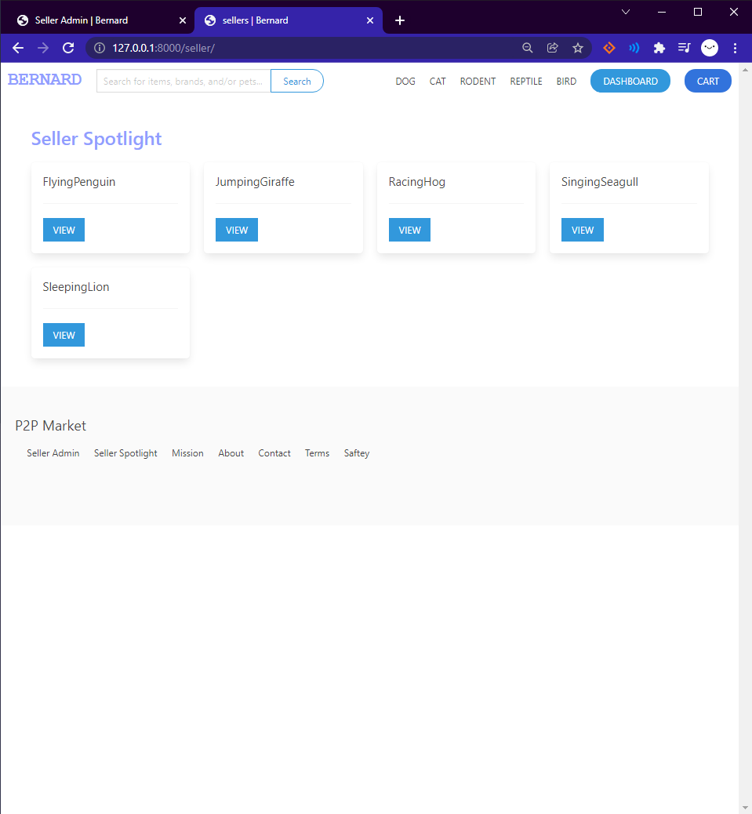

**Key Points:**

* Shows all the creators on the site, this is in order of the last poster, but could be designed differently with business logic.
* Will have implementation for cart
* Will make a way to have more than one image with proper html formatting

**Image 6: Seller Spotlight**

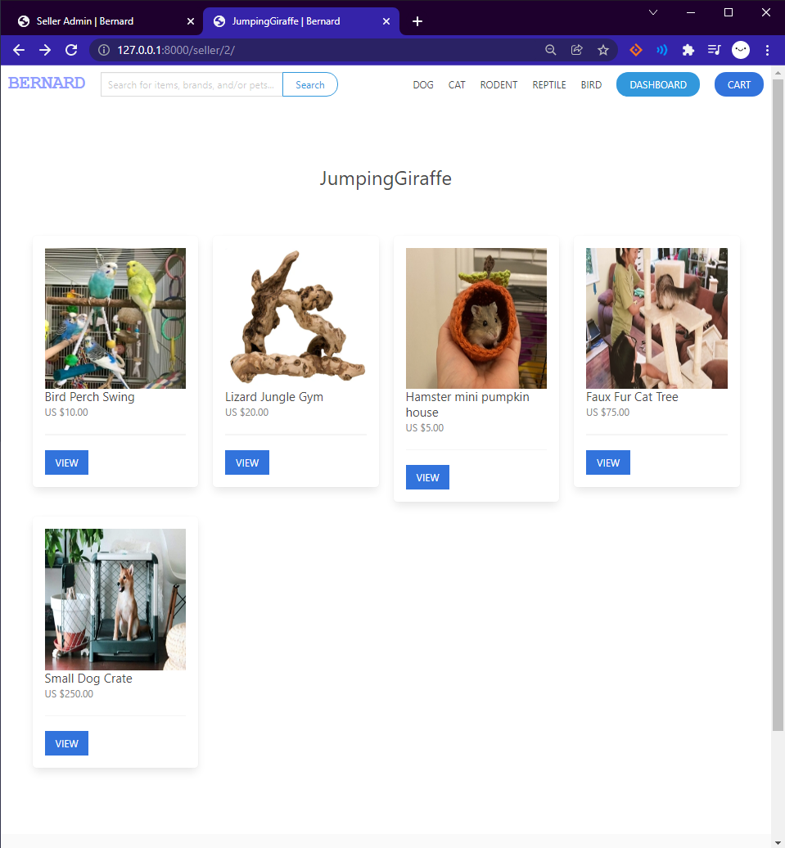

**Key Points:**

* Shows all the creators items on the site that they have posted